This document contains the fix to Libraries not found error.
1- Project developer guide.
2- User/.jar executable guide.

Project developer guide

The program needs at least 3 .jar libraries to work properly. If those libraries aren’t properly set inside the program libraries folder, as soon as the program is open it will show the next error:

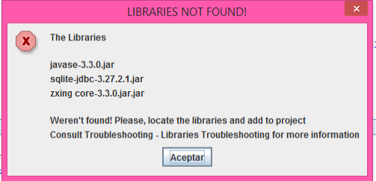
To fix this problem it is necessary to set the said 3 libraries.

Libraries needed:

- sqlite-jdbc-3.27.2.1.jar
SQLite library.

- javase-3.3.0.jar
Library needed to generate QR codes.

- zxing core-3.3.0.jar.jar
Library that generates QR codes.

Inside the NetBeans IDE do right click on “Libraries” folder:

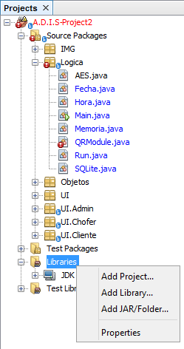
Click on “Add JAR/Folder...” label:

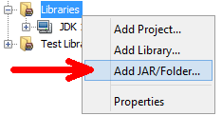
Go to root project folder and open the folder called “lib”:

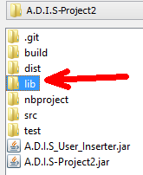
Inside the folder “lib” you will find “javase-3.3.0.jar”, “sqlite-jdbc-3.27.2.1.jar” and “zxing core-3.3.0.jar.jar” .jar files. Select all of them and click “Open” (“Abrir” in Spanish)

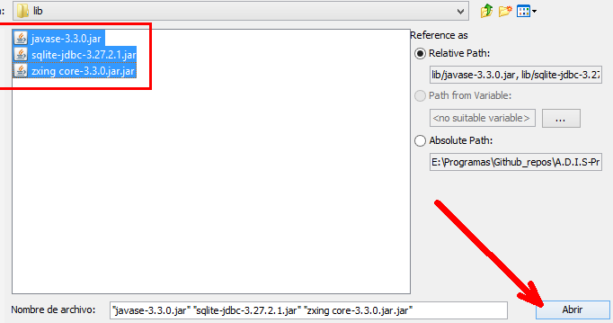

Doing this steps should fix the problem. If the libraries aren’t inside the “lib” folder try downloading the project again. If the libraries are still missing try searching them on the Internet, add them inside the “lib” folder and repeat the process.

User/.jar executable guide

The program needs at least 3 .jar libraries to work properly. If those libraries aren’t properly set inside the program libraries folder, as soon as the program is open it will show the next error:

To fix this problem it is necessary to set the said 3 libraries.

Libraries needed:

- sqlite-jdbc-3.27.2.1.jar
SQLite library.

- javase-3.3.0.jar
Library needed to generate QR codes.

- zxing core-3.3.0.jar.jar
Library that generates QR codes.

The program should be placed inside a path/folder that looks like this:
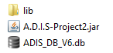
Inside the folder called “lib” should be the following .jar files:

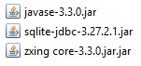
If one of those files is missing the program won’t work properly and will deploy the “Libraries not found” error.
To fix this problem, try downloading the project again and copy the .jar files inside the folder “lib”. If the .jar files are still missing try downloading them on the Internet and place them inside the “lib” folder.

